Alchemy, mimetics, immersion and consciousness.
Richard Brown

Honorary Senior Research Fellow,
The Victorian College of Art, Melbourne University
and artist in residence at the ABC.
E-mail: rb@mimetics.com

Abstract:
In this paper I discuss a number of ideas on the representation and perception of space, time and energy and how these ideas have been inspirational in creating experiential art works. Areas I have explored include the concept of a fourth dimension, alchemy, mimetics, immersion, artificial-life and ideas about the nature of consciousness. I carry out these explorations through “art as a mode of enquiry”, producing experiential artworks rather than written theory. This paper summarises a number of ideas I have found useful and inspiring in creating artworks that explore the perception and experience of space, time and consciousness.

Keywords:
The fourth dimension, space-time-energy, alchemy, mimetics, immersion, artificial-life, consciousness.

INTRODUCTION
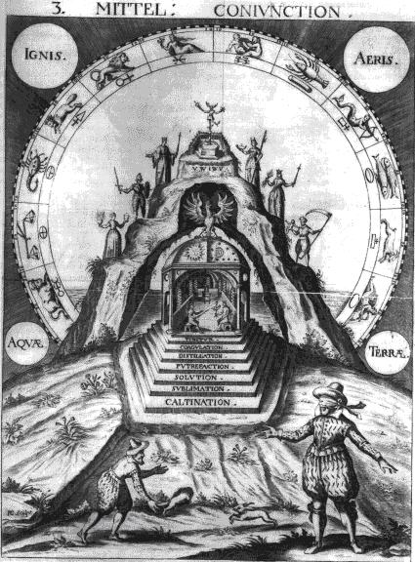
I regard myself as an explorer, inventor, experimenter and amateur alchemist. I use technology and science as a palette for expressing ideas concerning the perception and contemplation of space-time. This is not a new idea, artists such as Duchamp and the Cubists were inspired by ideas of non-Euclidean space and created works that explored alternative perceptions of space-time.
For those interested in finding out more about the historical relationships between 20th century art, science, mathematics, theosophy and the fourth dimension I would highly recommend reading “The Fourth Dimension and Non-Euclidean Geometry in Modern Art” by Linda Dalrymple Henderson [1].
The 20th century notion of the fourth dimension encompassed science, art and theosophy; simultaneously accommodating both a rational, reductive and an arrational, alogical synthetic approach to an understanding and conceptualisation of space-time.
I believe that consciousness is not amenable to simple reductionism and is poorly described by mechanistic and computational metaphor. Consciousness is something that is experienced and is perhaps best evoked looking askance, sideways, perhaps through story telling, the visual arts or some new and novel multi-modal methodology. Ouspenksy in Tertium Organum [2] discusses multiple modes of expression that might accommodate a new language of philosophy suitable for evolving an understanding of the deep complexes within that govern our consciousness of space and time.
I would like to suggest there are novel and as yet undiscovered means of expression that can simultaneously encompasses the rational, the emotional and the mystical. In The Glass Bead Game, Herman Hesse describes a similar philosophical ideology [3].
My aim is to create experiential constructions that somehow represent or evoke essential deep mental constructs that are not amenable to rationalisation or linguistic reductionism. If these works are to be immersive, they should be able to communicate, deeply and transparently, evoke a visceral and emotional resonance, and produce insight into “something other”.
I see this ideology of evoking a deep resonance through physical processes present in the practise of alchemy. That through the symbolic and contemplative interaction with key physical processes, the inner self might be changed, purified into something higher, personified by the infamous quest to make gold from base matter -
the so-called Philosophers Stone.
A full discussion on the nature of alchemy is not possible within this paper, here I present a number of key ideas and references that I find significant and inspirational.

Alchemy
I believe alchemy is somewhat misunderstood due to the popular belief that it was simply about a quest to find a method that would enable lead to be turned into gold. Many kings believed this myth and many an alchemist held to ransom under pain of death if they failed to produce the goods.
Alchemy is full of symbolism and the writings very arcane and esoteric. Much was purposely hidden, secretive and veiled. The image shown below (fig. 1) entitled “Conjunction”, combines symbolism and allegory to represent an alchemist at the third stage of an alchemical process. The image is from a collection held in the J.R. Litman Hermetic Philosophy library in Amsterdam [4].
Figure 1
‘conjunction’ 1616
The image is full of symbols – the 4 alchemical elements in the sky, the 12 signs of the zodiac and the 7 figures. The blind fold alchemist, the fleeing rabbit and the underground cave suggests an invisible and difficult earth bound journey. The 7 alchemical steps indicate the processes the alchemist must undergo in order to achieve transformation and realise a phoenix-like rebirth.
There were spin-offs to these esoteric undertakings and alchemists invented many of the precursors to modern chemistry and synthesised new materials such as porcelain [5].
“Of all the hermetic arts, its is alchemy that most directly anticipates modern science and its passion for material transformation.” [6]
It is now generally accepted that alchemy was also concerned with self-transformation, a journey to turn the base matter of the soul into something purer, more spiritually akin to gold. Carl Jung states:
“The alchemical opus deals in the main not just with chemical experiments as such, but with something resembling psychic processes expressed in pseudochemical language.” [7]
Alchemy is simultaneously about the transformation of physical matter and immaterial self, achieved through identification with both subjective and objective relationships during specific ritualistic processes.
The names given to these processes have wonderfully evocative names such as Decripitation, Conjunction, Sublimation, Dissolution - it is very easy to see how these descriptions can apply equally to psychological and physical processes. These processes are numerous and subtle, a list of 109 such alchemical processes can be found on the internet [8].
Jung went further to develop a meta-process he called ‘individuation’ and in his book Psychology and Alchemy [9] Jung draws many parallels between alchemical processes and those experienced in therapy.
“Only after I had familiarised myself with alchemy did I realise that the unconscious is a process, and that the psyche is transformed or developed by the relationship of the ego to the contents of the unconscious… through the study of these collective transformation processes and through an understanding of alchemical symbolism I arrived at the central concept of my psychology:
the process of individuation.” [10]
The web page www.alchemylab.com illustrates how some of these principles might be put into practice. The Emerald Tablet of Hermes Trismegistus is cited here as a fundamental starting point. The tablet, dated around 4AD, is engraved with a poetic text suggesting fundamental alchemical principles. [11]
I particularly relate to the commonly paraphrased alchemical motto “As Above, So Below” taken from one line of the Emerald Tablet:
“It is true without lies, certain and most true;
That which is below is as that which is above, and that which is above is as that which is below, to accomplish the miracle of the one thing…”
The idea that micro and macro structures are deeply nested, highly interconnected and perhaps irreducible, is an approach I see as relevant to complexity theory and emergence, and perhaps also to theories of consciousness.
Consciousness, Technology and magic
Scientist and sci-fi writer, Arthur C. Clarke is famously known for his view that any sufficiently advanced technology may be seen as magic [12]. I personally like the idea that technology can be used to create real practical magic, that it may be used to alter consciousness, to warp ideas about space and time.
In Techgnosis, Erik Davies writes:
“Magic is technology’s unconscious, its own arational spell. Our modern technological world is not nature, but augmented nature, super-nature, and the more intensely we probe its mutant edge of mind and matter, the more disenchanted productions will find themselves wrestling with the rhetoric of the supernatural.” [13]

The words mystical and spiritual seem to have negative connotations in the West. They may provoke either embarrassment or angry defensive analytical debate.
Is this a reaction to the rise of cults, new age phenomena and those seeking spiritual enlightenment?
Or is it a result of the West’s predilection with scientific empiricism, segregating these unwanted areas, classifying them as non-scientific, irrational or fundamentalist.
It’s almost as if a Global Mind battle is being fought for domination by the left and right hemispheres of our brains – when balance and synthesis is needed rather than opposition and conflict.

The idea of tension and opposites is very prevalent in Alchemy and is an essential idea in physics and chemistry. Electricity is both a familiar and alien entity, powerful, invisible, useful and ultimately mysterious and ineffable.
The separation of charge into negative and positive creates a tension, where electrons can flow or crash across the tension gap. This idea that a release of energy occurs when resolving tensions of opposition is a profoundly alchemical and esoteric idea. Hence the references to balance, male and female, dark and light.
Our understanding of space-time is shaped by our everyday perceptual mechanisms. Time is perplexing, it is seemingly artificial and malleable. Hypnosis, meditation, mind-altering substances, mental illness and accidental head injuries reveal how our perception of time may be altered.
The experimental work Stasis [14], a digital hypnosis system I presented at Consciousness Reframed 1998, serves as an example of how the experience of time may be modified through hypnosis.
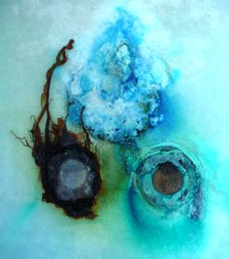
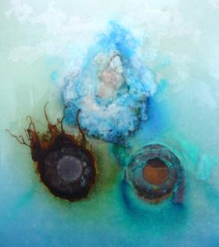
It is only through alternative ways of conceiving or imagining that I believe we will gain new insights and methodologies for envisioning greater views of space-time and perhaps also gain new insights into the nature of consciousness.
For example, many meditative, esoteric and transformative systems propose methods by which a higher form of consciousness might be attained. The Kabala, Tarot and alchemy are populated with systems that incorporate the use of number, sound, light, colour, perfume, symbols rituals and processes.
When contemplating the infinite, we ground ourselves, meditate on the irrational complexity and holism of
“The All”, finding that rationality has no place and is unbound. Journeys into the psyche are fraught with danger, represented as demons, anima, the shadow, Hades, the underworld. Jung was familiar with these perils and discusses the dangers and powers of individuation and the fear of the loss of ego [15].
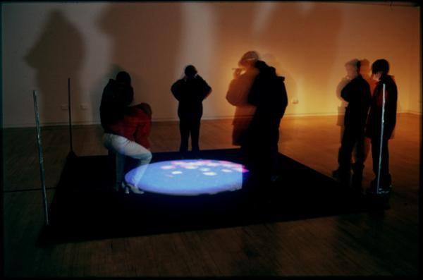
I believe that our comprehension of consciousness is highly bound to an understanding of space-time. Without the unfolding of space-time, everything is in stasis. I would like to suggest that everything that exists, that is about to be, and perhaps “was” may be thought of as an energy matrix, representing the transmutation of space-time. Nothing is static, all is motion and we perceive time via a memory of change as if through a “time window” – and thus have a limited ability to comprehend the changing multi-dimensional states, fluxes and processes occurring in the depths of space-time. Consciousness flows and is subject to influences beyond our everyday perceptions. It may be changed and shaped through contemplative, ritualistic and alchemical practises.
Through the creation of resonant systems, devices and installations I seek to create works that embody these ideas, evoking the richness and generally imperceivable complexities of deep space-time.
Creative works
My work is inspired by ideas about time, space energy and perception. The works have used a variety of media and taken many forms as described below.
I have used electrochemical and biological processes as a means of creating works that change over time, reflecting principles of tension, dynamics, opposition, flow of energy and transmutation.
When two dissimilar metals are placed in a conductive fluid, current flows and the metals corrode – the essential property of a battery.
The illustration below (fig.2) is an example of a work that has evolved in time over the last five years.

Figure 2
Electrochemical Glass
The Electrochemical Glass was created in October 1997, the two images were photographed in April 2002 and October 2002.
The metals copper, alluminium and iron are in conductive fluid sandwiched between sheets of glass. The resultant emergent time-based changes are complex, interactive and dynamic. The works acts as a daily reflection of process, decay, transmutation and growth; the slow changes resonating with memory and notions of self – a form of contemplative alchemy.
In 1996, I began developing the computer simulation of Dynamic Form at the Royal College of Art, under the banner “Art as a Mode of Enquiry” [16].
In 1997, I exhibited the interactive installation Alembic, [17] an alchemical term for distillation vessel (fig 3).
Figure 3
Alembic, interactive 3d installation
The work was inspired by ideas about the nature of Dynamic Form and its relationship to Alchemy.
The term Dynamic Form encapsulates the idea of form changing in space over time through interactions of energy.
My previous work explored physical manifestations of dynamic form such as electrochemical, kinetic, organic processes and high-voltage electricity.
In Alembic, “Virtual Reality” technology became a sculptural medium for the representation and manipulation of Dynamic Form, programmed in C and electronically interfaced.
Alembic abstracted the alchemical elements fire, air, earth, water as a interactive real-time computer generated 3D projection.
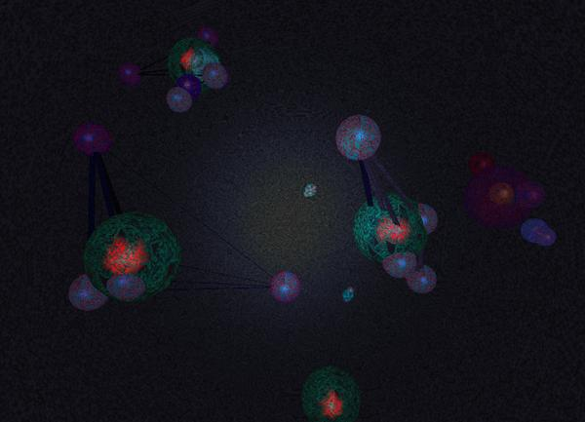
The viewer, wearing passive 3D glasses, sees a sphere cutting through the floor containing three-dimensional shapes that flow and transform in response to their position. The work reacts to the viewers location, by walking around the central projection, the temperature of the Alembic changes, causing matter to heat or cool. Fire is rushing particles, Air is cloud-like, Water flows as a form, earth crystallises to a solid. White noise sounds suggest the temperature changes from the roar of fire, the whoosh of air, the deep sound of water and the underground grumble of the earth.
The transmutation of the elements is suggested through their interactive responsive in movement and behavior, rather than through representational imagery (fig. 4).
Figure 4
Alembic images
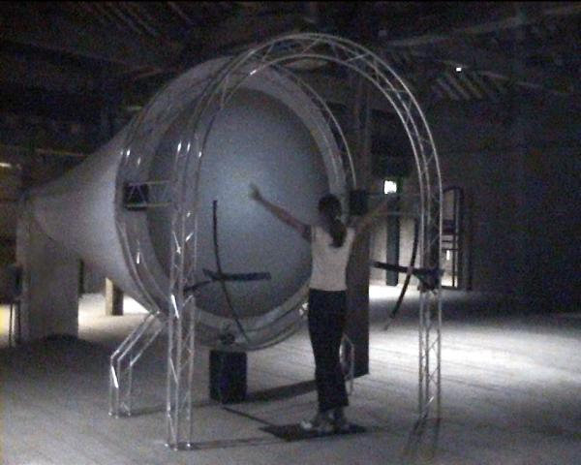
Alembic maps out changes of space, time and energy as responsive dynamic form. Alembic evokes a resonant process of transmutation through immersion and transparency. It is a work of contemplation and gentle body centric interaction, change and response, flow and time, transformation and perception.
Alembic simulated matter as particle physics, later I became interested in the idea of biological growth as a four dimensional process. What might be the principles by which form emerges in space-time?
This and other questions, plus research funding [18] led to the development of Biotica and a later commission for the Neural Net Starfish, works that represent examples of Artificial Life. My interest in this area stemmed from a desire to gain an understanding of the higher dimensional processes of biological growth, form and behaviour, and to create computer based illusions of life as visceral and resonant experiences.
Alembic used points, lines and triangles as its building bricks. Biotica started with a similar pure aesthetic using spheres and links to create a dynamic and evolvable network of simple electrochemical processors.
We named these basic elements “Bions”, which could acts as cells, particles, electrons, neurons.
A bion could be programmed with a Digital DNA code to reproduce, to connect, to act as a neuron, to create a muscular link etc.
Using simple electromagnetic fields and 3D game of Life like rules structures could be created that had simple life-like behaviors, akin to those seen through a microscope looking at pond water (fig. 5).
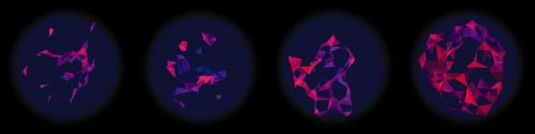
Figure 5
Biotica A-life creatures

Biotica was exhibited in the UK and at SIGGRAPH [19] as a large-scale 3D immersive interactive installation, the viewer would use their arms to fly through an abstract world of alien like life forms (fig. 6)

Figure 6
biotica installation
Biotica became a research project, an experiment into the investigation of principles of emergence as well as producing an immersive installation. Biotica opened up many avenues and research possibilities. It tried to ask the question - “what is it for something to be thought of as alive? ”. The research findings have been published as a book, Biotica: Art, Emergence and Artificial Life [20].

Originally I envisaged Biotica as a visceral experience, in retrospect I felt that the work had become too abstract, and was ultimately not as accessible as I would have liked. In response to this I created The Neural Net Starfish – this was designed from the start to be accessible, immediate, entertaining and group interactive. The work was first shown in the Millennium Dome, London 2000 and has since been shown as the Mimetic Starfish (fig. 7)
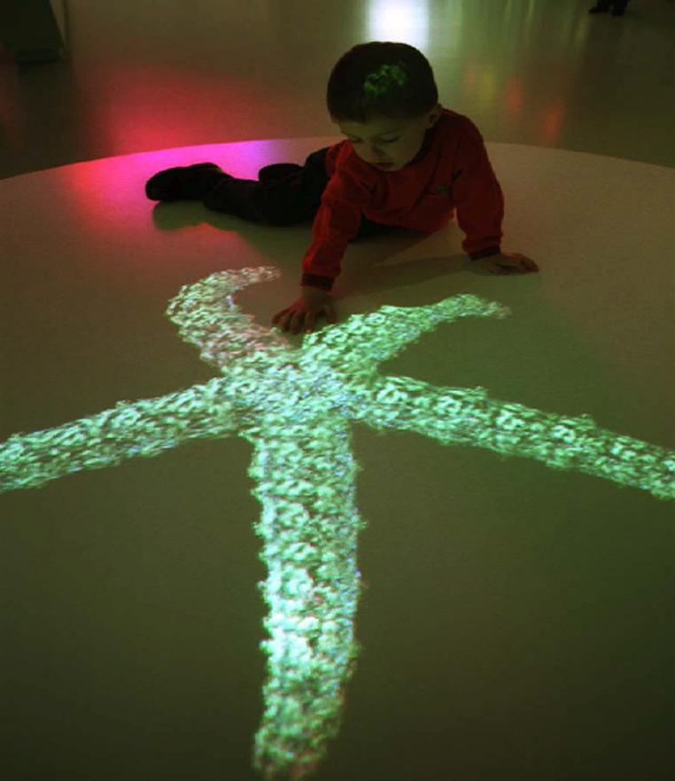
Figure 7
mimetic starfish
(image courtesy of cohne wolfe)
The mimetic starfish creates a sense of magic and illusion, it looks and behaves as if it were a real starfish.
A tentacle reaches out to the hand of an onlooker, if they move too quickly the tentacle retracts in an organic and fluid manner.
The starfish uses advanced principles of Dynamic Form, utilising higher space-time derivatives to create illusions of awareness and complex behaviour that resonates with real life.
The idea of illusion and resonance is encapsulated by the term ‘mimesis’ and in 2001 with support from NESTA [21], I began an independent research project, under the banner of mimetics. The website www.mimetics.com serves as a placeholder for this research.
My aim is to explore the creation of work that has a deep resonance with both nature and ‘other’, as exemplified in the mimetic starfish. The principles of mimetics may also be found in the kitsch, where re-representation of nature is used to evoke an emotive response in a naive, beguiling and transparent fashion.
The current experimental project mimesia is using these ideas in conjunction with games engine technology to create a work that encapsulates and evokes the concept of high-tech kitsch (fig. 8)
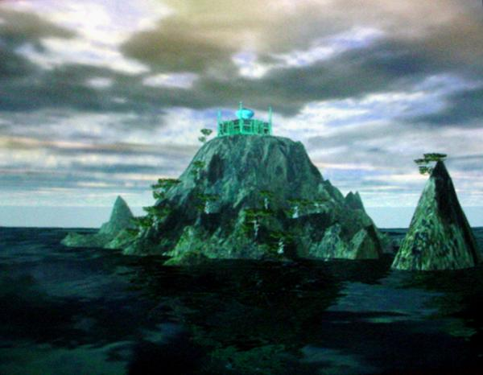
Figure 8
mimesia Games Engine image
Mimesia is envisaged as a real-time highly rendered, hyper-real experience of a dream like three-dimensional world. As in other kitsch work, mimesia has a dark side, exploring the roles of the archetype, the shadow and the unconscious. Mimesia will be presented as a wall hanging - an interactive hyper-kitsch painting.
The use of kitsch is a particularly interesting and powerful idea. Many examples of the history, function and role of the kitsch can be found in Celeste Olalquiaga’s wonderfully illustrated book
“The Artificial Kingdom“ [22].
Celeste describes how kitsch sits between nature and artifice, and is about wonder, fantasy and romanticism.
“Kitsch is this ability to surpass essential belongings and rest in more superficial ones, to create an imaginary landscape through accumulation and camouflage, and to crystallize the continuous movement of life in the permeable disguise of fantasy.” [23]
Through the crafting of games engine technology, the use of mimicry and illusion, it is intended that Mimesia will conjure up an escapist and imaginary dream-like world of fantasy and disguise, a knowing exemplar of the kitsch.
In parallel with this work, I am developing prototype commercial and accessible applications that explore ideas about space-time.
For further information please refer to my website, www.mimetics.com [24]

Conclusions
I would like to suggest that not everything is amenable to rational reductionism and that there are many other and as yet alternative and unknown “Ways of Knowing”.
Our abilities to go beyond the earthly ways of knowing tend to be restricted as a result of cultural forces, evolved perceptual and conceptual systems, and relatively undeveloped tools and language for exploring the inner.
My computer-based installations seek to create a sense of wonder, of magic. Ideally the works are transforming experiences that slide under our analytical radar, causing a deep sub-conscious resonance. My interest in mimetics parallels this quest, that through the use of mimicry, resonant illusions might be created that cause an instant non-analytical emotive response – be it of beauty or repulsion. I see this present in the art of the kitsch – which commonly has negative connotations associated with poor taste. However the very act of creating work that has popular appeal and produces an emotive responsive is something I see as powerful and of interest to the artist.
In the West we tend to be rather brain bound, being overtly analytical, materialistic and culturally opposed to the spiritual. Alchemy suggests that through the participation in symbolic alchemical processes, a melding of the outer material world with the immaterial world of the inner may be achieved. The transformation occurring through an identification of and resonance between key internal and external processes.
My proposal is that in a similar manner to alchemy, technology may be used to create “practical magic”, a means of contemplating and revealing both inner and outer space-time processes.
To conclude, I seek to create works that are both accessible and meaningful. I use technology as a medium to explore and evoke ideas of consciousness, the spiritual and the connections that might be made between the profound and the mundane.

Technical Details
My interactive installations are computer-based works that use “real-time interactive 3D graphics”. The works are real-time in that the 3D graphics respond to changing external parameters without any noticeable delay. The programs are written in C or C++ and use OpenGL or Direct3D with a 3D graphics card.
Alembic simulates the behaviour of matter as simple point based particles. Biotica is also a particle simulation with additional processing properties to synthesise neural net and spring linkages, and reproduction based on chemical gradients. These biological like particles named bions have a simple cellular programming language enabling them to be programmed so that bions reproduce and form connections in response to information from surrounding bions. The programming of a bion acts as a “digital DNA” enabling Artificial-life creatures to be “grown” from a single bion.
The Mimetic Starfish is a pre-defined three-dimensional neural net and spring structure, with additional seeking behaviour programmed into the bions. The organic movement and behaviour of the starfish result from the combination of neural net interactions, seeking behaviour and the simulation of spring-like muscles attached to the bions.
All my installations make use of sensing technologies to create works that are transparent and immersive.
The works are transparent as the body is intuitively used to interact with the work. They are immersive through the combination of large-scale video projection, ambient audio and engaging interactive content.
Alembic and Biotica respond to body interaction through the use of a Theremin-like device produced by MIT known as the “electric-fish” [25]. This device senses the variation of tuned radio waves between a number of electrodes. When a hand is brought near the electrodes, the signal is diminished and this information can then be used to determine the location of a hand or body.
The Mimetic Starfish senses the location of participants hands using an infrared camera, video frame grabber and machine vision software [26] that generates the position of each hand.
Mimesia has been realised through the use of a games engine Power Render [27], C programming and 3D design software (3DStudio Max). The sensing technology is a web camera coupled with pattern recognition software (VisualMouse [28]) that enables the mouse cursor to be controlled by head movements. This information is used to control the point of view of the camera as it moves along a pre-defined path in the virtual world.

REFERENCES

- Henderson, Linda Dalrymple, The Fourth Dimension and Non-Euclidean Geometry in Modern Art, Princeton University Press 1983.
(soon to be republished by MIT Press)
ISBN 0-691-10142-62.
- Ouspensky, P.D., Tertium Organum, Vintage Books, Random House 1970.
- Hess, Herman, The Glass Bead Game, 1943, English translation, 1957.
- J.R Ritman Hermetic Philosophy library, http://www.xs4all.nl/~bph/index.html
- The Chinese held the secret to the manufacture of porcelain. In the quest to create gold, a European alchemist synthesised this new material. Marshall, Peter, The Philosophers Stone, p43. Macmillan 2001, Pan Books 2002.
ISBN 0 330 48910 0
- Davies, Erik, Techgnosis, p36.
Three Rivers Press, Random House 1998.
ISBN 0-609-80474-X
- Jung, C.G., Psychology and Alchemy, p242.
London, Routledge, 1953;
Princeton University Press ,1968.
ISBN 0 415 034523
- List of 109 Alchemical processes: http://members.tripod.com/purple_lace/id104_m.htm
- Ref. 7
- Jung, C.G., Memories, Dreams, Reflections, p235.
London, Collins Fountain Books, 1977.
- Emerald Tablet, Hermes Trismegistus
http://www.alchemylab.com/emerald_tablet.htm
detailed translations can be found at:
http://www.levity.com/alchemy/emerald.html
- Clarke, Arthur C., Profiles of the Future, 1964 Bantam Books. Arthur C. Clarke states his three Laws:
http://www.lsi.usp.br/~rbianchi/clarke/ACC.Laws.html
- Ref. 6, p38
- Stasis, Digital Hypnosis:
http://www.crd.rca.ac.uk/staff/richard/stasis.html
Consciousness Reframed:
http://www.caiia-star.net/production/ConRef/
- Ref. 7, p 336.
- “Virtual Unrealities”, research at the Royal College of Art, 1996-2001.
http://www.crd.rca.ac.uk/staff/richard
- Alembic, images and description of installation.
http://www.crd.rca.ac.uk/staff/richard/alembic.html
- Research Funding from Intel Corporation (Applications, Interface and Media), Wellcome Trust Sci-Art, Arts Council of England and support from Interval Research at the Royal College of Art.
- SIGGRAPH 2000, New Orleans, America.
http://www.siggraph.org/s2000/
- Brown, Richard, Biotica: Art, Emergence and Artificial Life, CRD Research, Royal College of Art, 2001.
ISBN 1-874175-33-0
- NESTA, National Endowment for Science Technology and the Arts. UK funding body.
http://www.nesta.org/
- Olalquiaga, Celeste, The Artificial Kingdom, A Treasury of the Kitsch Experience.
Bloomsbury Publishing 1999.
ISBN 0-7475-4535-9
- Ref 22, p 174.
- Mimetics website commenced December 2001. http://www.mimetics.com/
- MIT Fish:
http://web.media.mit.edu/~jrs/efs.html
- Stemmer machine vision toolkit:
http://www.stemmer-imaging.de/
- Power Render games engine:
http://www.3dengine.ca/
- VisualMouse:
http://www.mousevision.com

